Directions for Safety Demo Box Construction
Material Preparation
- Rip one (1) 2” x 4” x 10’ board into two 1 ½” x 1 ½” x 10’ pieces
- Cut one (1) 2” x 4” x 8’ board into two (2) 48” segments
- Crosscut the 7/16” OSB into (1) 18” x 48” section
- Using the two ripped 10’ board sections, make the following series of crosscuts
  - Four (4) at 11” long
  - Two (2) at 18” long
  - Four (4) at 14 ½” long
  - Three (3) at 15” long
- Cut the plexiglass sheet into three (3) 18” x 18” pieces and one (1) 18” x 15 7/8” piece.
  - Note: Use laminate/non-ferrous blade for cutting plexiglass
- Cut two (2) pieces of scrap 2x4 into 12-18” lengths.
Frame Assembly
- Begin by assembling the back piece and supports using #8 x 1 ¼” exterior screws. Note – Holes should be predrilled to avoid cracking boards.
  - Attach the two (2) 2” x 4” x 4’ pieces to the edges of the 18” x 4’ OSB so that the boards span the length of the OSB.
    - Using #8 x 1 ¼” exterior screws, place one screw in each board at center (24”), ¾” from the top, 4” from top and bottom, and 12” from top and bottom. All should be placed in the approximate center of the board.
  - Once this is complete, the 1 ½” x 1 ½” x 11” pieces can be mounted between the two 4’ 2x4’s.
    - Attach one to the edge of the back, flush with the bottom.
    - Measure and mark 15” from the top of the board and attach the next 11” piece so that the bottom is level with that mark.
    - Repeat with the remaining two boards, ending with the last board flush with the top of the back.
    - Attach each with a screw in the center (9”) and one each at approximately 3 ½” from the left and right edge of the plywood.
- With the back finished, begin assembling the box. Note – Holes should be predrilled to avoid cracking boards.
  - Create a U-shaped frame by attaching one of the 18” pieces to two (2) of the 14 ½” pieces. The 14 ½” pieces should be flush the ends of the 18” piece.
    - Attach by putting one 2” screw into the face of the 18” board at each end.
    - Repeat this process with remaining 18” and 14 ½” pieces.
  - Mount one of these pieces to the bottom of the back, ensuring the ends are flush.
    - Use 1 ¼” screws through the plywood to attach frame.
  - Lay the project on its side and attach two (2) of the 15” pieces to the two corners of the bottom frame.
    - Predrill a hole through the bottom side of the 18” piece up into the 15” piece. Do this on both ends.
    - Then, toenail a 2” screw into each of the predrilled holes.
  - With project standing back upright, rest the other U-shaped piece on top of the 15” uprights and mount to the back of the board.
    - Be sure edges are flush and the top of the piece is exactly 18” from the bottom of the back on both sides.
      - Use 2” screws through the plywood to attach.
    - With that done, the piece may then be attached to the two uprights.
      - Predrill a hole from the top side of the 18” piece into the upright on both ends.
      - Toenail a 2” screw into the predrilled hole.
  - Lastly, the final 15” piece needs to be attached to the back, even with the second back support. If done correctly, it should fit perfectly between the upper part of the box frame.
    - Use three screws to fasten, one in the center (9”) and one 4 ½” from the left and right edges respectively.
    - Attach by sinking a 2” screw through the plywood and 11” support.
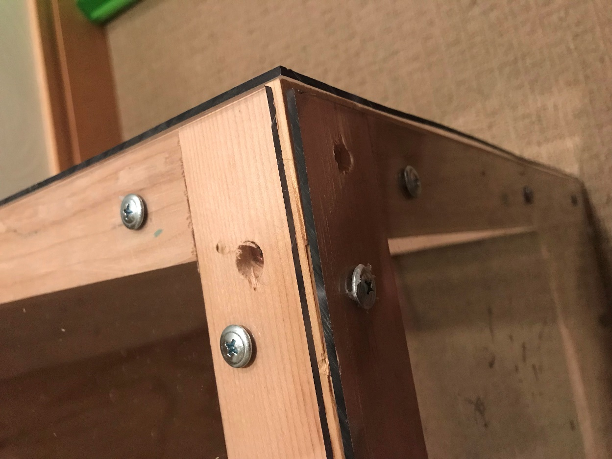
- With both the back and the frame complete, the pre-cut plexiglass can be attached to the outside of the box. Note – Again, holes should be predrilled to avoid cracking boards.
  - Using ¾” screws, attach the 3 18” x 18” pieces to the left, front and right sides of the box.
  - Use the following pattern:
    - Attach one screw in the center of each side (9” from edge)
    - 2 ½” from each corner, attach another screw
    - In total there should be 12 screws in each of the three plexiglass faces.
  - The last plexiglass piece will be attached to the top of the box.
    - Follow the same pattern as before, but don’t put a screw into the center of the edge closest to the back.
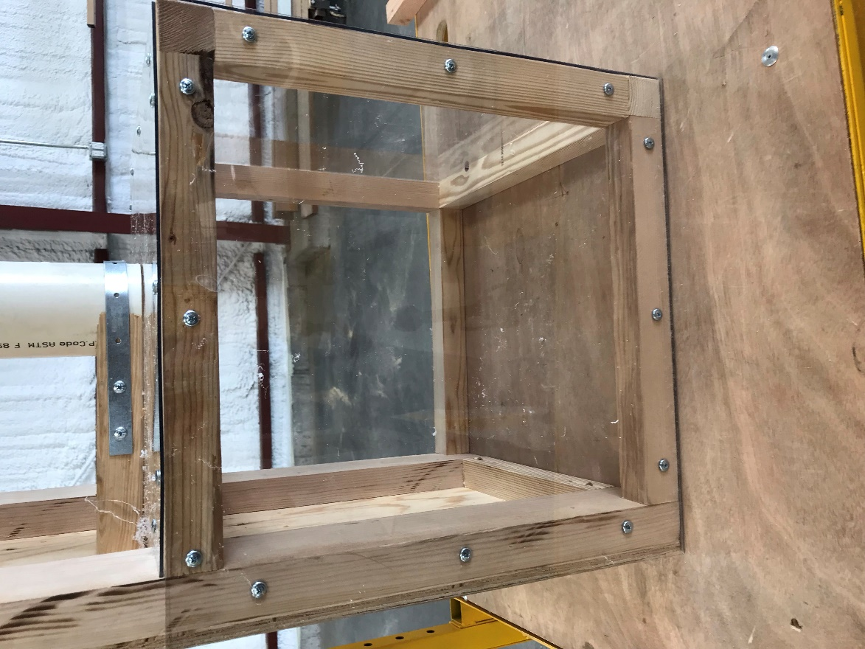
Drop Mechanism Assembly
      - With a permanent marker, make a small cross in the center of the top plexiglass face.
        - Mark 9” in from the left side of the plexiglass and then mark 7 15/16” from the back edge of the plexiglass.
      - Using a 3” bi-metal hole saw, drill a hole in the center of the cross created.
      - Next, take the two scrap pieces of 2x4 (between 12 and 18” in length) and using the PVC as a guide, mark out a concave half circle (the idea is for the board to “cup” the PVC when cut out.
        - Using a jigsaw and bandsaw, cut out the half circles.
      - Before attaching anything, center the PVC pipe over the hole in the plexiglass.
        - The easiest way to do this is to look down the pipe from directly overhead, ensuring no plexiglass is on the inside of the pipe.
      - With the PVC centered, measure from the back of the board to the nearest outside edge of the PVC. Measurement should be around 7 ½” to 8”.
        - Cut the scrap 2x4 (the one with the half circle) to this length, measuring from the base of the circle to the end of the board.
      - Attach both boards to the box, one directly on top of the plexiglass, and the other one on top of the 11” support above.
        - Attach using two 2” screws for each board, making sure to predrill each hole.
      - Take the two 15” steel straps and bend them into a U shape around the PVC.
        - Attach one side to the 2x4 with a ¾” screw.
        - Pull the other side tight and attach a ¾” screw
        - Put one more screw in each side after this is done.
        - Repeat with second strap.
